Automatic assembly of PCR products with Web PCR

Assembly of PCR products from the sequences of primers and template sequence is possible using any sequence editor (like ApE), but it is tedious and error prone.

There is an on-line web service called WebPCR that can do this for you. This service can predict the sequence of the PCR products given the sequence of the primers and of the template.

Go the web page: http://pydna.pythonanywhere.com. You should see a window like Fig 1.

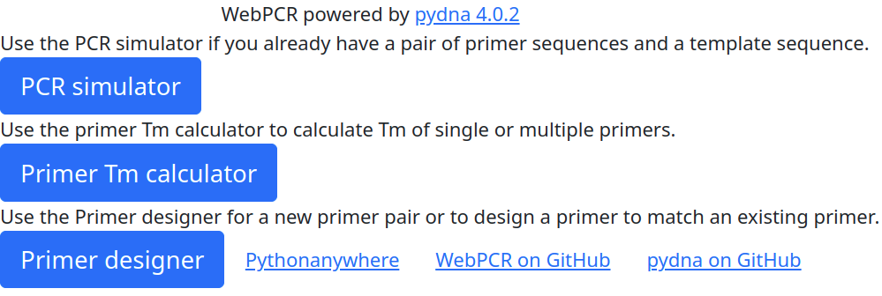Fig 1

Click on the PCR simulator button You should now see a site similar to the one in Fig 2.

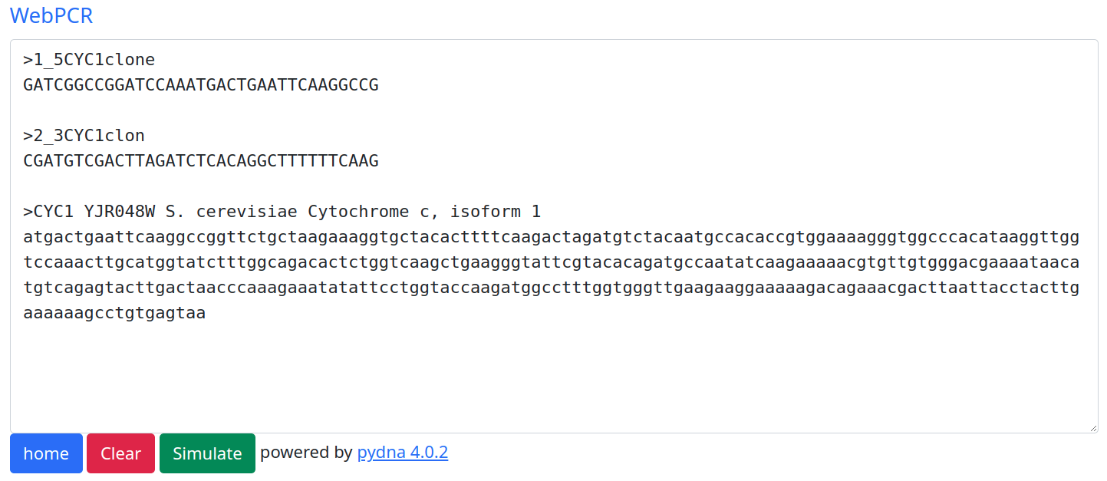Fig 2: PCR simulator

The window accepts pasted sequences in FASTA or Genbank formats. The last of the sequences is assumed to be the template, all other sequences are assumed to be primers:

This means that you can add more than two primers if you like. Delete all text in the window of Web PCR and paste the following three sequences in the window. The sequences in are also available in the “primers_and_template_sequences.txt” file that should be present in the same folder as this document.

>2_3CYC1clon
CGATGTCGACTTAGATCTCACAGGCTTTTTTCAAG

>1_5CYC1clone
GATCGGCCGGATCCAAATGACTGAATTCAAGGCCG

LOCUS YJR048W__Chr_10_ 2330 bp ds-DNA linear 05-JUN-2012
DEFINITION .
ACCESSION
VERSION
SOURCE .
ORGANISM .
COMMENT >YJR048W Chr 10 from 525335 to 527664
COMMENT ApEinfo:methylated:1
FEATURES Location/Qualifiers
misc_feature 959..1003
/label=New Feature
misc_feature 1327..1372
/label=New Feature(1)
ORIGIN
1 GAGGCACCAG CGTCAGCATT TTCAAAGGTG TGTTCTTCGT CAGACATGTT TTAGTGTGTG
61 AATGAAATAG GTGTATGTTT TCTTTTTGCT AGACAATAAT TAGGAACAAG GTAAGGGAAC
121 TAAAGTGTAG AATAAGATTA AAAAAGAAGA ACAAGTTGAA AAGGCAAGTT GAAATTTCAA
181 GAAAAAAGTC AATTGAAGTA CAGTAAATTG ACCTGAATAT ATCTGAGTTC CGACAACAAT
241 GAGTTTACCA AAGAGAACAA TGGAATAGGA AACTTTGAAC GAAGAAAGGA AAGCAGGAAA
301 GGAAAAAATT TTTAGGCTCG AGAACAATAG GGCGAAAAAA CAGGCAACGA ACGAACAATG
361 GAAAAACGAA AAAAAAAAAA AAAAACACAG AAAAGAATGC AGAAAGATGT CAACTGAAAA
421 AAAAAAAGGT GAACACAGGA AAAAAAATAA AAAAAAAAAA AAAAAAAGGA GGACGAAACA
481 AAAAAGTGAA AAAAAATGAA AATTTTTTTG GAAAACCAAG AAATGAATTA TATTTCCGTG
541 TGAGACGACA TCGTCGAATA TGATTCAGGG TAACAGTATT GATGTAATCA ATTTCCTACC
601 TGAATCTAAA ATTCCCGGGA GCAAGATCAA GATGTTTTCA CCGATCTTTC CGGTCTCTTT
661 GGCCGGGGTT TACGGACGAT GGCAGAAGAC CAAAGCGCCA GTTCATTTGG CGAGCGTTGG
721 TTGGTGGATC AAGCCCACGC GTAGGCAATC CTCGAGCAGA TCCGCCAGGC GTGTATATAT
781 AGCGTGGATG GCCAGGCAAC TTTAGTGCTG ACACATACAG GCATATATAT ATGTGTGCGA
841 CGACACATGA TCATATGGCA TGCATGTGCT CTGTATGTAT ATAAAACTCT TGTTTTCTTC
901 TTTTCTCTAA ATATTCTTTC CTTATACATT AGGACCTTTG CAGCATAAAT TACTATACTT
961 CTATAGACAC ACAAACACAA ATACACACAC TAAATTAATA ATGACTGAAT TCAAGGCCGG
1021 TTCTGCTAAG AAAGGTGCTA CACTTTTCAA GACTAGATGT CTACAATGCC ACACCGTGGA
1081 AAAGGGTGGC CCACATAAGG TTGGTCCAAA CTTGCATGGT ATCTTTGGCA GACACTCTGG
1141 TCAAGCTGAA GGGTATTCGT ACACAGATGC CAATATCAAG AAAAACGTGT TGTGGGACGA
1201 AAATAACATG TCAGAGTACT TGACTAACCC AAAGAAATAT ATTCCTGGTA CCAAGATGGC
1261 CTTTGGTGGG TTGAAGAAGG AAAAAGACAG AAACGACTTA ATTACCTACT TGAAAAAAGC
1321 CTGTGAGTAA ACAGGCCCCT TTTCCTTTGT CGATATCATG TAATTAGTTA TGTCACGCTT
1381 ACATTCACGC CCTCCTCCCA CATCCGCTCT AACCGAAAAG GAAGGAGTTA GACAACCTGA
1441 AGTCTAGGTC CCTATTTATT TTTTTTAATA GTTATGTTAG TATTAAGAAC GTTATTTATA
1501 TTTCAAATTT TTCTTTTTTT TCTGTACAAA CGCGTGTACG CATGTAACAT TATACTGAAA
1561 ACCTTGCTTG AGAAGGTTTT GGGACGCTCG AAGGCTTTAA TTTGCAAGCT TCGCAGTTTA
1621 CACTCTCATC GTCGCTCTCA TCATCGCTTC CGTTGTTGTT TTCCTTAGTA GCGTCTGCTT
1681 CCAGAGAGTA TTTATCTCTT ATTACCTCTA AAGGTTCTGC TTGATTTCTG ACTTTGTTCG
1741 CCTCATGTGC ATATTTTTCT TGGTTCTTTT GGGACAAAAT ATGCGTAAAG GACTTTTGTT
1801 GTTCCCTCAC ATTCCAGTTT AGTTGTCGAC TGATACTGTT AATAAACTCA TCGGGCGAGG
1861 CTTCCACGGT TGGAAAAGCA TATGGGCTGG CGCATATGGT TATAAAATCA CCTTTTTGCA
1921 ATTCAATTCT ATCTTTCCCA TCAAAAGCCG CCCATGCTGG AGCCCTTGAC TTCATCGAGA
1981 CTTTCACTTT TAAATTTATA CTTTCTGGTA AGATGATGGG TCTGAAACTC AATGCATGTG
2041 GACAAATGGG TGTTAAAGCG ATTGCATTGA CGGTTGGGCA TACCAATGAC CCACCTGCAC
2101 TCAAAGAATA GGCCGTGGAC CCAGTCGGAG TAGCAGCAAT CAGTCCGTCC GCCTGCGCAA
2161 CGGTCATTAA TGAGCCGTCA CCATACAATT CTAACATGGA TAGAAAAGGA CTTGGACCAC
2221 GATCGATGGT CACTTCGTTC AAAATGTGGT GTGTGCTTAG TTTTTCCACC ACACATATTT
2281 TCTTCCCCGT GTTTGGGTCT ACTTCAGGGC GGTGTCTACG ATAAATTGTG
//

click “Run simulation” you should now get the following output below the window (next page):

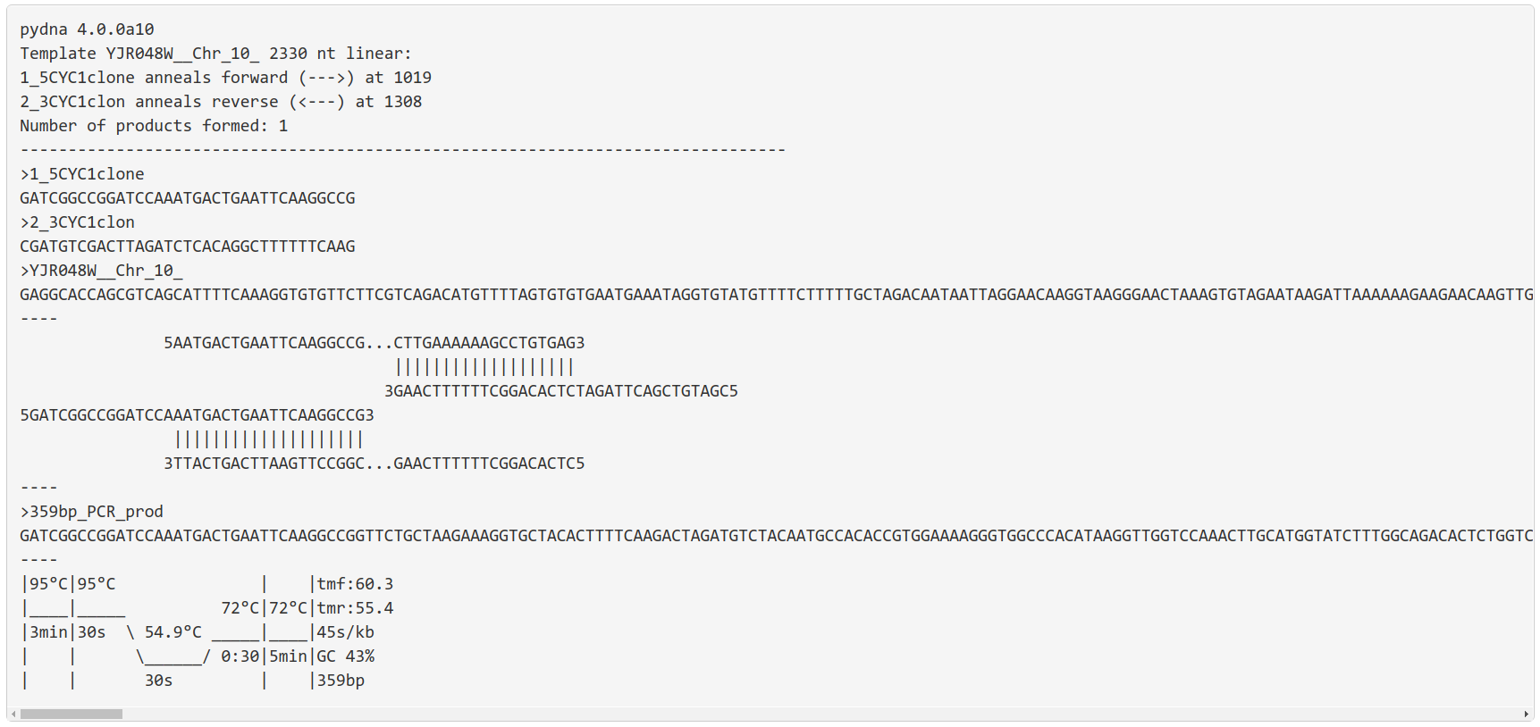Fig 3: CYC1 PCR product
The simulation found one potential PCR product of 359 bp. The report has five parts. The first part (below) tells us general things about the template molecule (name, size and if it is linear or circular).
pydna 4.0.0a10
Template YJR048W__Chr_10_ 2330 nt linear:
1_5CYC1clone anneals forward (--->) at 1019
2_3CYC1clon anneals reverse (<---) at 1308
Number of products formed: 1
--------------------------------------------------------------------------------

The second part gives us the primers and the template PCR product in FASTA format.

>1_5CYC1clone
GATCGGCCGGATCCAAATGACTGAATTCAAGGCCG
>2_3CYC1clon
CGATGTCGACTTAGATCTCACAGGCTTTTTTCAAG
>YJR048W__Chr_10_
GAGGCACCAGCGTCAGCATTTT...GATAAATTGTG
----
The third part is a figure showing how the primers anneal on the template.

----
5AATGACTGAATTCAAGGCCG...CTTGAAAAAAGCCTGTGAG3
|||||||||||||||||||
3GAACTTTTTTCGGACACTCTAGATTCAGCTGTAGC5
5GATCGGCCGGATCCAAATGACTGAATTCAAGGCCG3
||||||||||||||||||||
3TTACTGACTTAAGTTCCGGC...GAACTTTTTTCGGACACTC5
----
The fourth part has the PCR product in FASTA format. The product is given in the direction of the primers.

----
>359bp_PCR_prod
GATCGGCCGGATCCAAATGACTGAATTCAAGGCCGGTT...AGTCGACATCG
----
The fifth an final part suggests PCR programs using either Taq polymerase or Pfu-Sso7d (such as PfuX7 or the commercial Phusion for example.

----
Taq DNA polymerase
|95°C|95°C | |tmf:62.4
|____|_____ 72°C|72°C|tmr:59.1
|3min|30s \ 48.7°C _____|____|45s/kb
| | \______/ 0:30|5min|GC 47%
| | 30s | |48bp
Pfu-Sso7d DNA polymerase
|98°C|98°C | |tmf:56.7
|____|_____ 72°C|72°C|tmr:53.8
|30s |10s \ 56.8°C _____|____|15s/kb
| | \______/ 0:10|5min|GC 47%
| | 10s | |48bp

Question 1:

Use the sequences in the file “primers_and_template_sequences2.txt” file that should be present in the same folder as this document.

Check the SEGUID of the PCR product.

The first five characters of the SEGUID are ifnuA
What are the last five?

Question 2:
This is an individual question for each student. Follow this link that points to a Google Spreadsheet. You should find your name in the leftmost column. Three columns called primer1,2 and template contains DNA sequences representing primers and a template. Your task is to use the WebPCR service to simulate the PCR. Put your result in the indicated cell for forward primer (product). Please answer with a raw DNA sequence as indicated for the first example student "Max Maximus". This will speed up correction. If your name is *not* in the list, please inform your instructor.

